PROJECT REPORT TEMPLATE

1.INTRODUCTION

* Our project is under the topic ‘SUBSCRIBERS GALORE EXPLORING WORLD’S TOP YOUTUBE CHANNELS’.
* In our project we depict many contents related to youtube and the recent statistics about youtube as well as its history.
* The purpose of our project is to enable and provide knowledge to the viewers of the project in every nooks and corners.

2.PROBLEM DEFINITION AND DESIGN THINKING

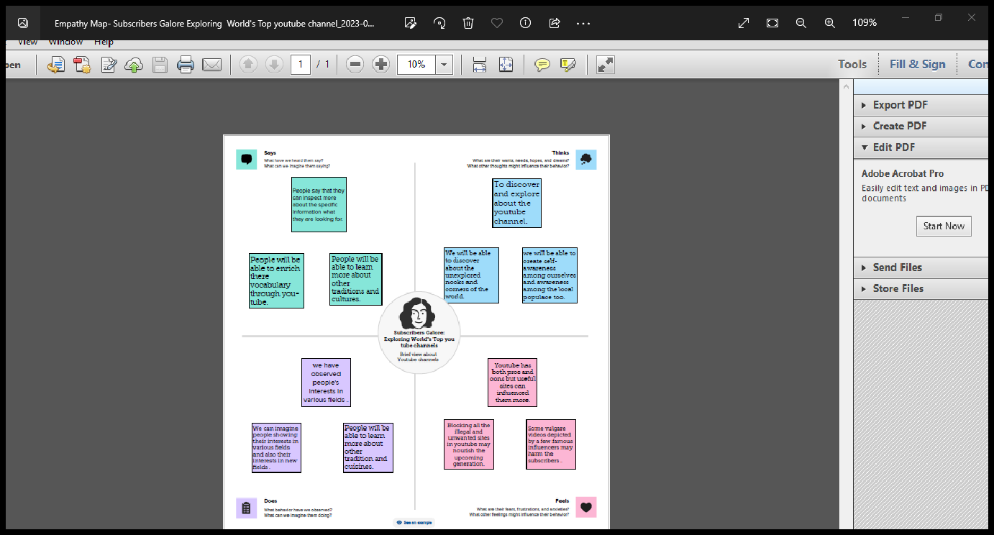3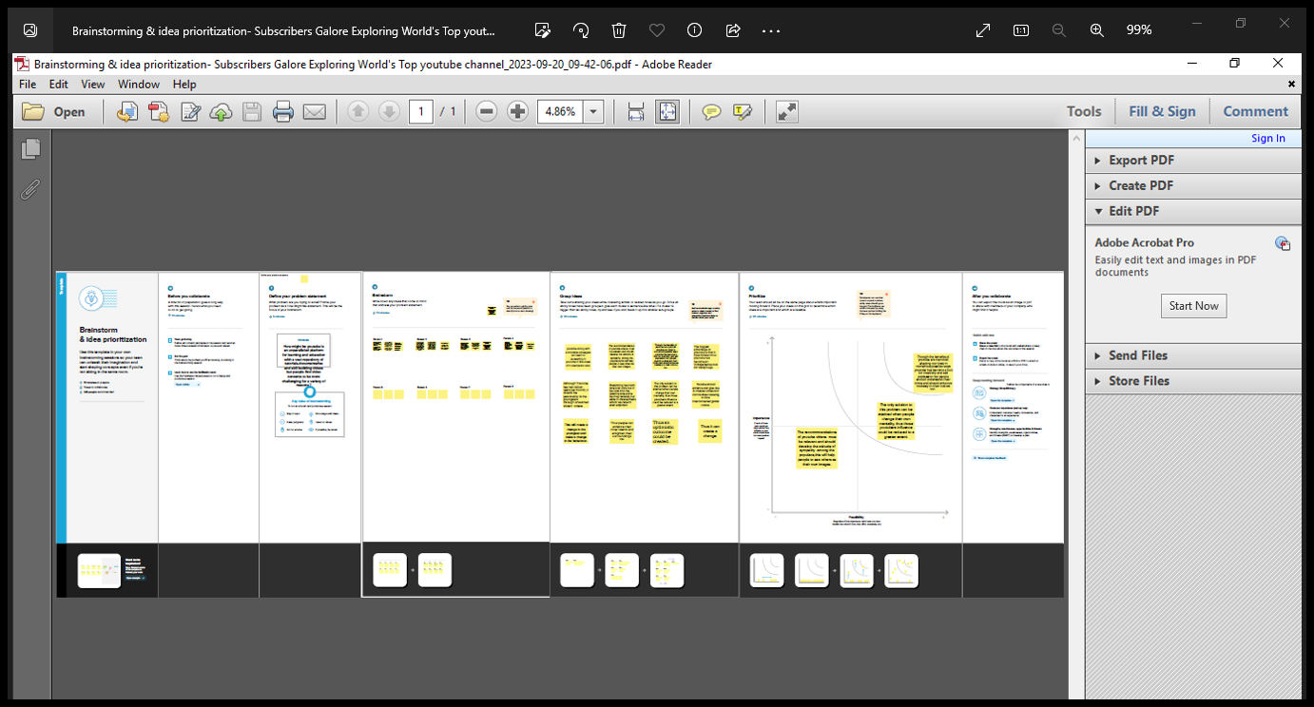 3.RESULT

* The project enabled the viewers to understand the list of world’s top youtube channels.
* We students came to know more about youtube and the unknown feeds about youtube.

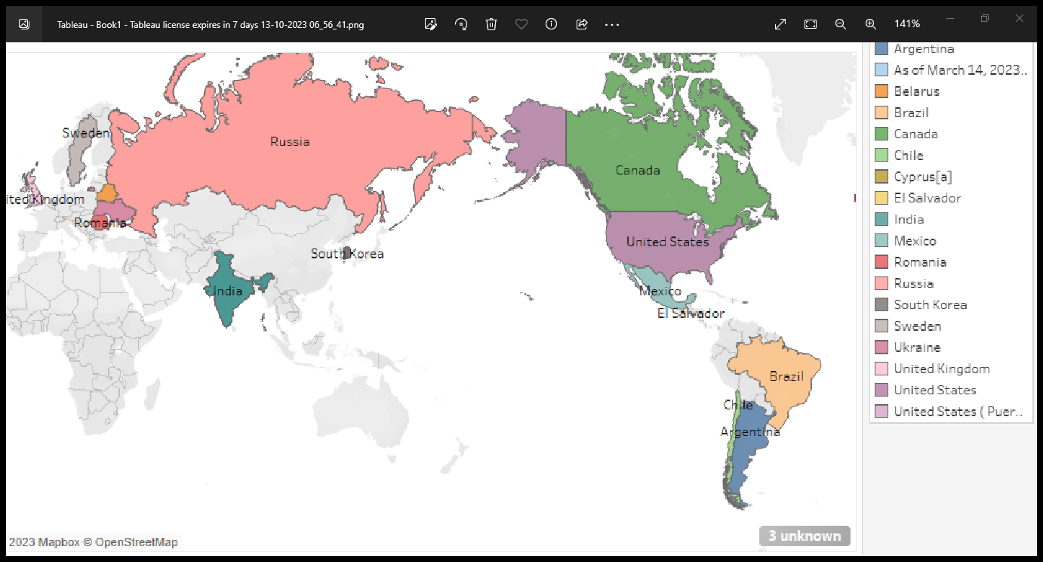

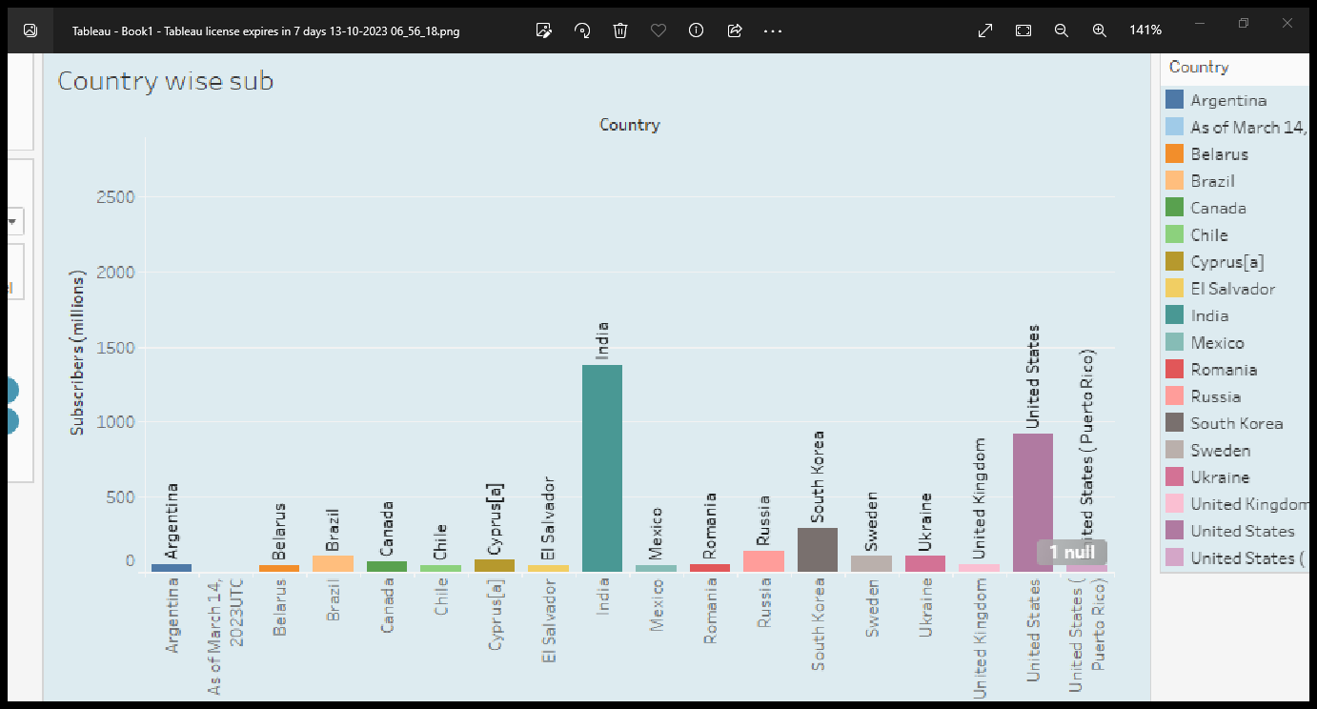

4.ADVANTAGES AND DISADVANTAGES

* ADVANTAGES :
* We were able to find various contents in youtube and we were able to know more about the rate of subscribers as well we were able to display dashboards and also makeup a story in this project apart from learning .
* We were able to work with co operation and share each of our opinions in the project display.
* DISADVANTAGES:
* We need the content to reach the rural people also and the people in the remote areas as this is available only in urban areas.

5.APPLICATIONS

* We can apply this statistics and analysis in each and every field of this modern and advanced globe .
* We can nourish the local areas also with youtube analysis .

6.CONCLUSION

* We were able to develop data making skills and from the entire project we were able to know abou the No.of channels ,no.of subscribers ,map analysis etc,.

7.FUTURE SCOPES

* We can find that the subscribers ratio is the highest in India ,so it can promote people to enrich their skills in various fields and it can make our country as the BIGGEST SOURCE OF INVESTMENT AND MARKETING IN FUTURE FOR SURE .

THANK YOU ALL.